1. On what basis we can filter the emails?

Ans) One way to do this is by filtering emails based on different criteria like **subject, date, body content, or sender.**

1. Package for mail activities**?**

**Ans)** Studio provides email automation capabilities through the **UiPath.Mail .Activities Pack.**

This activity package is designed to facilitate the automation of any mail-related tasks, **covering various protocols, such as IMAP, POP3 or SMTP**. UiPath also features activities that are specialized for **working with Outlook and Exchange**.

1. How Email Can be Interacted in Rpa Perspective?

Ans) From an RPA perspective, two situations for interacting with email are: Email as the input and email as the output for our process.

1. Usage of Input Emails and Output Emails?

Ans) **Input Emails**: For input emails, we can receive the data in textual form, as part of the **subject** or **body** of the email, or as an attachment, for example an Excel file, a pdf or other file types.

**OutPut Emails:** As for email as output, it is most commonly used for sending status updates to supervisors regarding different automation projects or when business or application exceptions occur

1. What is IMAP?

Ans) Then IMAP or **Internet Message Access Protocol** which is only used for receiving messages, but offers some useful features to mark messages as read or move them between folders.

1. **GET IMAP MAIL MESSAGE** Properties?

Ans) **TimeoutMS:** Specifies the amount of time (in milliseconds) to wait for the activity to run before an error is thrown. The default value is 30000 milliseconds (30 seconds).

**Host**

1. **MailFolder :** The mail folder from which the messages are to be retrieved

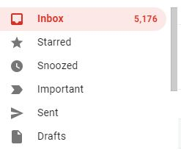

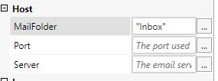

Eg: :”Inbox”

“Starred”

“Snoozed”

1. **Port & Server:**

**Server** - The email server host that is to be used.

**Port** - The port used to get the email message.

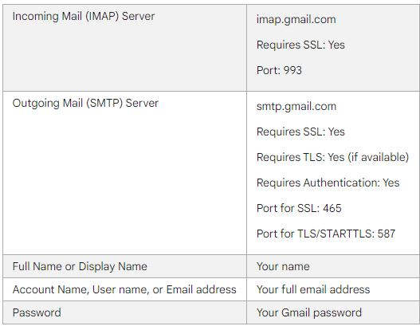

**Use Server-**(For Gmail) - imap.gmail.com

**Use Port(**For Gmail**)-** 993

**Logon**

1. **Email -** The email account used to get the message.(USE GMAIL ID)
2. **Password-** The password of the email account used to get the message.(USE GMAIL PASSWORD)
3. **Secure Password-**  The password of the email account used, as a secure string(Use get Password Activity and create the password variable over there and insert this variable over here)
4. What is the Output of Get IMAP Mail Messages?

Ans) The retrieved messages as a collection of MailMessage objects.(List of Mail Messages)